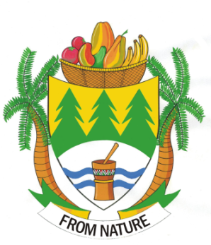

**INTERNAL MEMORANDUM**

**ENGINEERING SERVICES DEPARTMENT**

|  |
| --- |
| **TO : CHIEF FINANCIAL OFFICER**  **FROM: DIRECTOR ENGINEERING SERVICES**  **DATE: 21 FEBRUARY 2019** |

**SCHEDULE OF SERVICE DELIVERY STANDARDS - ENGINEERING SERVICES DEPARTMENT**

**WATER SERVICES**

Water Quality rating : Blue Drop.

Free water available to all : No, only to the indigent consumers.

Frequency of meter reading : Per month.

Duration (hours) before availability of water is restored in cases of service interruption -

* One service connection affected : 3 hours.
* Up to 5 service connection affected : 6 hours.
* Up to 20 service connection affected : 12 hours.
* Feeder pipe lager than 800mm : 24 hours.

Do you practice any environmental or scarce resource protection activities as part of your operations? –Yes.

How long does it take to replace faulty water meters – 1 day

**SEWERAGE SERVICES**

Are your purification system effective enough to put water back in to the system after purification? – Yes and we are green drop compliance.

How long does it take to restore sewerage breakages on average?

* Severe spillage : 24 hours.
* Sewer blocked pipes : Large pipes – 12 hours.
* Sewer blocked pipes : Small pipes – 6 hours.
* Spillage clean-up : 24 hours.
* Replacement of manhole covers : 12 hours.

**ROAD INFRASTRUCTURE SERVICES**

Time taken to repair a single pothole on a major road : 24 hours.

Time taken to repair a single pothole on a minor road : 48 hours.

Time taken to repair a road flowing an open trench service crossing : 24 hours.

Time taken to repair walkways : 48 hours.

Kind Regards,

**……………………….  
Mr. CW Molokomme**

**Director Engineering Services**